|  |  |  |  |  |
| --- | --- | --- | --- | --- |
| **Qualitative and quantitative analysis of prednisone chemical content in rheumatic herbs in Magelang Region**    **Riza Nur Afifah1, Arief Kusuma Wardani1*, Tiara Mega Kusuma1**  1 Program Studi Farmasi, Fakultas Ilmu Kesehatan, Universitas Muhammadiyah Magelang, Magelang, Indonesia | | | | |
| DOI: [https://doi.org/10.29303/sjp.v6i1.358](https://doi.org/10.29303/sjp.v6i1.358%20) | | | | |
| **Article Info** | | | | | **Abstract:** Currently, there is a phenomenon that shows that many herbs consumed by the public contain medicinal chemicals (BKO). This study aims to identify the presence of BKO prednisone in rheumatic herbs and its levels. This study took five types of samples of rheumatic herbs in Magelang area with different brands, namely samples of herbs A, B, C, D and E, which are available in capsule and powder form. Identification of prednisone in rheumatic herbs was carried out using thin layer chromatography (TLC) method with silica gel GF254 as stationary phase and ethyl acetate: chloroform mixture (4:1) as mobile phase. Quantitative analysis was performed using UV-Vis spectrophotometry with a maximum wavelength of 238.5 nm. The rf value of prednisone standard 0.42 was obtained and quantitative analysis showed that the prednisone content in sample B in the first replication was 3.22%, in the second replication was 2.18%, in the third replication was 2.23%. | |
| Received | | **:** | | 2024-01-18 |
| Revised | | **:** | | 2024-11-29 |
| Accepted | | **:** | | 2024-12-24 |
|  | | | | | **Keywords:** BKO Prednisone; KLT; UV-Vis Spectrophotometry. | |
|  | | | | |  | |
| **Citation:** | | | Afifah, R. N., Wardani, A. K., & Kusuma, T. M. (2025). Qualitative and quantitative analysis of prednisone chemical content in rheumatic herbs in Magelang Region. *Sasambo Journal of Pharmacy*, *6*(1), 1-6. doi: [https://doi.org/10.29303/sjp.v6i1.358](https://doi.org/10.29303/sjp.v6i1.358%20) | | | |

**Introduction**

According to the Indonesian Food and Drug Administration (BPOM), jamu is the simplest type of traditional medicine, consisting of plant ingredients, animal ingredients, mineral ingredients, galenic preparations, or a mixture of these ingredients that have been used for generations (BPOM, 2023). Scientific proof of efficacy and safety is based on hereditary evidence. Jamu may not have efficacy claims using pharmacological/medical terms and the raw materials used are not required to be standardized, but must still meet applicable quality requirements (Marwati et al., 2021).

Currently, there is a phenomenon that shows that many herbs consumed by the public contain medicinal chemicals (BKO). The results of the intensification of traditional medicine supervision by BPOM show that there are various types of traditional medicines containing BKOs totaling 879 items (10,585 pcs). This is a concern because herbal medicine should consist of natural ingredients without a mixture of chemicals. According to BPOM, the use of BKO in herbal medicine can be harmful to health, especially if used for a long period of time. Therefore, it is important to increase public awareness in choosing herbal medicine that is safe and free from BKO (BPOM Semarang, 2023).

The results of previous research conducted by Wirastuti, (2016), related to prednisone content in rheumatic herbs in Makassar using the KLT-Densitometry method, which showed that only one type of herbal medicine, namely herbal medicine A, contained prednisone with a level of 475.421 µg/ml. Another study conducted by Fikayuniar, (2021), related to the identification of prednisone in rheumatic and pegal linu herbs in West Karawang using the UV-Vis spectrophotometric method, resulted in the finding that there were five herbal medicine samples that were positive for prednisone BKO. In the UV-Vis spectrophotometric analysis, it was found that herbal medicine sample J had the highest average prednisone content, 0.7833%, with a concentration of 30 ppm. Based on previous research conducted by Fitrianasari et al., (2023) related to the qualitative analysis of BKO in rheumatic herbs using samples circulating in herbal medicine depots in the Keranggan Temanggung area and markets in Magelang city using the thin layer chromatogaphy (KLT) method, the results showed that herbal medicine samples in the region did not contain BKO. This study involved the analysis of samples circulating in herbal medicine depots in the Magelang region, which have the potential to contain BKOs, using TLC and UV-Vis Spectrophotometry methods. Therefore, it is necessary to conduct further research on rheumatic herbs sold in herbal medicine depots circulating in the Magelang region to obtain more comprehensive information on the presence of BKO in herbal medicine.

**Materials and Methods**

**Collection of Rheumatic Herb Samples**

This study used five samples of rheumatic herbal medicines with initial brands A, B, C, D, and E, each differing in brand, packaging, and composition. Sampling was carried out using a probability sampling technique from a group of rheumatic herbs. One sample was a concoction of herbs in powdered form, while the other four samples were packaged herbs, consisting of one in capsule form and three in powdered form.The sampling process was conducted over two months in the Magelang region, including the Bandongan area with two samples, the Tegalrejo area with one sample, the Tempuran area with one sample, and the Salaman area with one sample.

**Qualitative Analysis by Thin Layer Chromatography (TLC)**

**Sample Preparation**

Weigh 1 gram of herbal medicine sample A, put it into a 50 ml Erlenmeyer. Add 96% ethanol as much as 20 ml, cover with aluminum foil. Then sonicated for 20 minutes (Tahir et al., 2018). Do the same treatment for samples B, C, D, E as sample A.

**Preparation of Mobile Phase**

Mix ethyl acetate and chloroform in a ratio of 4:1 into the chamber. Insert saturation paper into the chamber and close it. Wait until the space in the chamber becomes saturated, marked by saturation paper eluent to the limit mark.

**Preparation of Standard Solution (Prednisone Tablet Standard)**

Crush some prednisone tablets with a mortar and pestle. Weigh 100 mg of prednisone powder, put it in a 10 ml volumetric flask, then add methanol and distilled water in a ratio of 1: 1 until the limit mark (Prayoga et al., 2016).

**Preparation of Standard Comparison Solution (Prednisone Pure Standard)**

Weigh 100 mg of prednisone pure standard powder, put it in a 10 ml volumetric flask, then add methanol and distilled water in a ratio of 1: 1 until the limit mark (Prayoga et al., 2016).

**Preparation of KLT Plate**

The separation of compounds extracted by sonication was performed using a TLC plate as the stationary phase with a size of 4cm x 10cm. Additionally, a line mark is made at the bottom edge of the plate at a distance of 1 cm to indicate the initial position of the spots and 1 cm from the top edge of the plate to indicate the limit of the elution process.

**Samples and Comparators**

The standard bottling of prednisone tablets, samples, and pure standards is sequentially done on the KLT plate, with as many as three spots applied using a capillary pipe, then dried in the air.

**Elution Process**

Substances that had been bottled on the plate were then eluted with the mobile phase. The plate was inserted into a chamber containing a saturated mobile phase, placed in the middle position of the chamber, and the chamber was closed tightly until the mobile phase reached a distance of ±1 cm from the top edge of the plate. Then, the plate was lifted and air-dried.

**Stain Identification**

The stains formed on the KLT plate are then observed and marked under UV light at a wavelength of 254 nm.

**Determination of Rf value**

Next, the distance traveled by each stain is measured and the Rf value is calculated, using the formula:

$$Rf=\frac{Analyte migration distance}{Migration distance of eluent}$$

**Quantitative Analysis by UV-Vis Spectrophotometry**

**Preparation of 100 ppm Standard Solution**

Weigh 50 mg of prednisone, put into a 100 ml volumetric flask. Then add with 96% ethanol until the limit mark (500 ppm). The solution was pipetted as much as 10 ml, then put into a 50 ml volumetric flask. Add 96% ethanol until the limit mark (100 ppm).

**Determination of Maximum Wavelength**

Prednisone 100 ppm standard solution was pipetted sufficiently and transferred into a cuvette. Then read the absorbance on a UV-Vis spectrophotometer with a wavelength of 200-300 nm.

**Preparation of Standard Solution Series**

From the 100 ppm standard solution, a concentration variation was made, namely 5 ppm, 10 ppm, 15 ppm, 20 ppm and 25 ppm.

**Preparation of Standard Curve**

The results of the preparation of the standard solution series were then measured at the maximum absorption wavelength obtained in the previous wavelength measurement and ethanol 96% as used as a blank. The absorbance results obtained at each concentration variation are entered into linear regression so that the standard curve equation is Y = bx + a.

**Determination of Prednisone Level in Samples**

Weigh 50 mg of rheumatic herbs, dissolve in 10 ml of 96% ethanol, homogenize. The stock solution was pipetted as much as 2 ml, put in a 10 ml volumetric flask, add with 96% ethanol until the limit mark, homogenize. The solution was pipetted as much as 0.5 ml, put in a 10 ml volumetric flask, add 96% ethanol to the limit mark, homogenize. The sample solution was measured for absorbance at UV-Vis spectrophotometry (Sesil Aquarius 7400) with a wavelength of 238.5 nm.

**LOD and LOQ Method Validation**

The least analytical concentration levels that the device can measure are the Limit of Detection (LOD) and Limit of Quantification (LOQ) values in studies employing the calibration curve approach (Pranoto et al., 2021).

**Resultand Discussion**

One of the rheumatological disease groups is rheumatism, a condition that shows pain and stiffness in the limbs, including gout, is one of the common and often faced rheumatic diseases in Indonesia. Prednisone is often mixed in jamu as an effort to relieve symptoms such as rheumatism, gout, aches and pains, and shortness of breath. Prednisone is a type of corticosteroid drug, which is clinically utilized in the treatment of various health problems, both acute and chronic, such as joint inflammation, asthma, and allergies. However, the use of prednisone that is not in accordance with the dosage or medical recommendations can potentially cause side effects such as facial swelling, bone problems, digestive disorders, muscle problems, hormonal imbalances, psychological disorders, osteoporosis (Wirastuti et al., 2016).

This study aims to identify the presence of BKO prednisone in rheumatic herbs and its levels. This study took five types of samples of rheumatic herbs in Magelang area with different brands, namely samples of herbs A, B, C, D and E, which are available in capsule and powder form.

To extract the active substances in herbal medicine, a sonication method is used. The purpose of using the sonication method is to break up small bubbles that contain gas in them, with the intention of increasing the purity of the phase (Anugraini et al., 2018). This extraction process uses 96% ethanol as a solvent. The use of ethanol is based on the volatility of the solvent at the time of sampling, which can affect the movement of compounds in the sample during elution (Kemenkes RI, 2020).

To detect the presence of prednisone in rheumatic herbs, qualitative and quantitative analysis was conducted. In qualitative analysis, using the KLT method with silica gel GF254 as the separation medium. The reason for using the KLT method is because this method has the advantage of a relatively short analysis time, about 60 minutes, as well as simple equipment and requires a small number of samples. The implementation technique is quite simple and does not require extensive laboratory space (Pratama Ridwan et al., 2017). In the KLT method, the identification of BKO prednisone in rheumatic herbs is carried out based on the comparison of the rf value of each sample with the rf value of pure standard prednisone and prednisone tablets. Before the rf value can be identified, each sample of rheumatic herbs and the comparator is photographed on a TLC plate, then eluted with a mixture of ethyl acetate and chloroform (4:1), then the rf value is calculated. To determine the rf value, a comparison between the rf value of the standard and the sample was used. After that, it was evaluated with a 254 nm UV lamp. Under the illumination of UV lamp 254 nm, prednisone tablet standard and pure prednisone will produce purple and intense purple colored spots that have an rf value of 0.42. While under the illumination of UV lamp 366 nm, the spots are not visible. In confirming the presence of prednisone, it is said to be positive if the rf value of the sample is the same as the rf value of the standard comparator.

The use of tablet prednisone and pure prednisone as standards aims to ensure the validity and accuracy of the analysis. Pure prednisone is used as the primary reference due to its high purity, while tablet prednisone is used to reflect the conditions of actual preparations, including the potential interference from excipients. (eksipien). The combination of these two standards allows for more relevant, accurate, and reliable testing, and helps obtain valid results in accordance with actual conditions.

At 254 nm UV lamp illumination, sample A showed a spot with a purple color that had an rf value of 0.51. Meanwhile, herbal medicine sample B showed a more intense purple spot with an rf value of 0.42. Sample C showed a lighter purple spot with an rf value of 0.23. Samples D and E, both showed patches with a yellow color that had rf values of 0.77 and 0.75, respectively. Of the five samples in the UV lamp 366 nm did not appear spot. When compared between standards and samples, it can be said that the suspected BKO prenisone is in sample B, because between the two standards and sample B has the same spot height presented in Figure 1 and the same Rf value presented in table 1.

**Table 1.** Results of qualitative analysis of prednisone

in rheumatic herbs by TLC

|  |  |  |
| --- | --- | --- |
| **No** | **Herbal Medicine Name** | **Rf Value** |
| 1 | Standard tablet prednisone | 0,42 |
| 2 | Pure standard prednisone | 0,42 |
| 3 | Sample A | 0,51  0,67 |
| 4 | Sample B | 0,42  0,67 |
| 5 | Sample C | 0,23 |
| 6 | Sample D | 0,77 |
| **7** | Sample E | 0,75 |

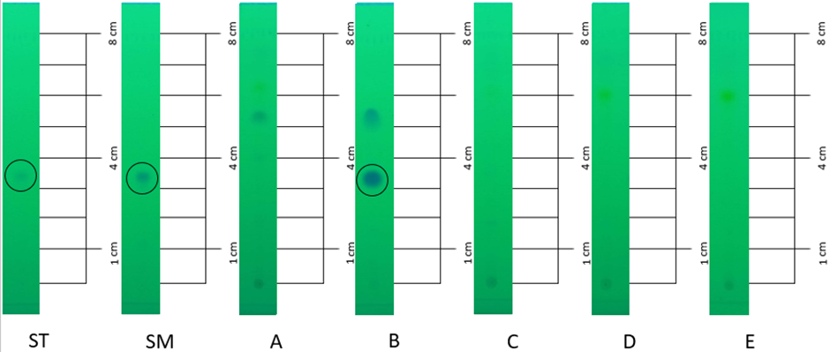

**Figure 1**. Visualization of spots of rheumatic herbal medicine samples (A-E) with a UV lamp at 254 nm using standard tablet (ST) and pure standard (SM) prednisone after elution with ethyl acetate: chloroform (4:1) mobile phase.

After completing the qualitative analysis, the next step is to conduct a quantitative analysis to determine the amount of prednisone in the sample of jamu B which is proven to contain prednisone BKO in the determination of prednisone levels in tablets according to the Indonesian Pharmacopoeia with High Performance Liquid Cromatography (HPLC) because it has good accuracy and precision, but the needs required have an expensive cost and longer analysis time (Kemenkes RI, 2014). From these aspects, it can be concluded that using the HPLC method is not suitable for regular quality control. Instead, the UV-Vis spectrophotometric method can be used as an alternative test method as an analysis of prednisone levels in tablets, because prednisone has chromophore and ausochrome groups (Primaharinastiti & Helwandi, 2016).

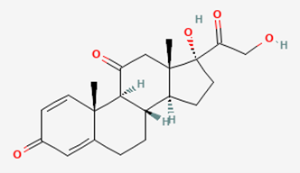

**Figure 2**. Chemical structure of prednisone

UV-Vis spectrophotometry is a testing method that has advantages in terms of relatively fast analysis time and more affordable operational costs, but still provides high accuracy in quantitative analysis of compounds that have chromophore and auxochrome groups (Darmawati et al., 2016). Chromophore groups refer to groups that have conjugated double bonds, while auxochrome groups refer to functional groups that have free electron pairs (Kemala Sari et al., 2020). Prednisone, based on its structure, has conjugated double bonds and carbonyl groups as chromophore groups, as well as OH groups as auxochrome groups, as presented in **Figure 2**. The basic principle of UV-Vis spectrophotometry is that when monochromatic light passes through a medium, some of the light is absorbed by the medium, some is reflected, and some is re-emitted (Yanlinastuti & Syamsul Fatimah, 2016). Quantitative analysis was carried out using the UV-Vis spectrophotometric method, where the maximum wavelength was carried out by measuring the absorbance of the prednisone standard at a concentration of 100 ppm by observing the wavelength in the range of 200-300 nm. The level of the compound was calculated based on the results of measuring the absorbance of the sample using the regression equation obtained from the prednisone standard curve.

The minimum analytical concentration values that can produce a sufficiently large signal to be identified are known as the limit of detection (LOD) and limit of quantification (LOQ). The limit of quantification (LOQ) is the concentration of an analyte that produces a signal greater than the blank, or the smallest concentration of the analyte in the sample that can be detected with good precision and accuracy under the agreed-upon procedure conditions.

**Table 2.** Results of LOD and LOQ Testing

|  |  |
| --- | --- |
| **Item** | **Absorbance** |
| R | 0,9959 |
| SD | 0,0216 |
| LOD | 2,1442 |
| LOQ | 7,1475 |

**Table 3.** Results of Quantitative Analysis of Prednisone Levels in Rheumatic Hour Samples

|  |  |  |  |
| --- | --- | --- | --- |
| **Sample B** | **Sample Weight** | **Absorbance** | **Content** |
| Replication1 | 514 mg | 0,573 | 3,21% |
| Replication 2 | 516 mg | 0,411 | 2,17% |
| Replication 3 | 508 mg | 0,415 | 2,23% |

In **Table 3**, the results of the quantitative analysis of the ethanol extract from rheumatic herbal medicine samples using the UV-Vis spectrophotometry method reveal that the highest level of prednisolone contamination was recorded in the first replicate, followed by the third and second replicates. The standard curve of prednisolone has a linear equation of y=0.0303x + 0.0721, with a linear regression value (r2) of 0.9919, which is less than one. Meanwhile, the correlation coefficient (r) is 0.995 with an r2 value of 0.9919, as shown in **Figure 3**, indicating a high degree of conformity between absorbance (y) and the measured level (x). An r value approaching 0.999 indicates very good measurement quality. After completing the qualitative analysis stage for five different brands of rheumatic herbal medicine samples, followed by quantitative analysis aimed at determining the prednisone content using UV-Vis spectrophotometry at a wavelength of 238.5 nm, the results are presented in **Figure 4**.

**Figure 3.** UV-Vis spectrophotometric curve graph of prednisone

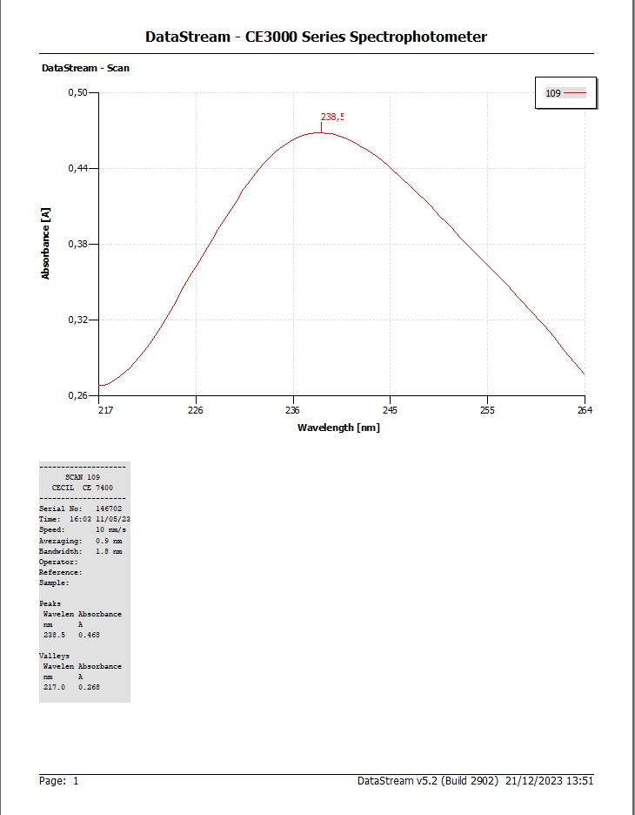

**Figure 4.** The wavelength curve of prednisone with a concentration of 200-300 nm

It was found that sample B contains prednisone with an average of 2.53%.In a previous study conducted by Wirastuti et al., (2016), it was found that prednisone levels in rheumatic herbs in Makassar, especially in herbal medicine A, reached 475.421 µg/ml. while in a different study conducted by Fikayuniar, (2021), it was revealed that prednisone levels in rheumatic herbs in Karawang, especially in herbal medicine J, were 0.7833%.

Some differences with previous studies are in the brand of herbal medicine used, sampling locations, methods applied, and results obtained. The previous study involved samples of rheumatic herbs scattered in the Makassar area, the method used was qualitative analysis using KLT and quantitative analysis using TLC-densitometry, resulting in one positive sample containing prednisone. Then another study, sampling was carried out in Karawang which showed one positive sample of jamu J containing prednisone. While in the latest study, qualitative (KLT) and quantitative (UV-Vis spectrophotometry) analysis was conducted on samples of rheumatic herbs taken in the Magelang region, including Bandongan, Tempuran, Tegalrejo, and Salaman. The results showed that only one sample, sample B, was suspected to be positive for prednisone.

**Conclusion**

The results of the study showed that of the five samples of rheumatic herbs circulating in the Magelang area, only one sample, namely sample B, contained the BKO prednisone. Quantitative analysis showed that the prednisone level in sample B in the first replication was 3.22%, in the second replication was 2.18%, in the third replication was 2.23%. This finding indicates the potential for non-conformity in rheumatic herbal medicine products, especially if the use of prednisone is not in accordance with the appropriate medical purpose or if the levels contained exceed safe limits. Therefore, it is recommended to conduct further evaluation regarding the safety and regulations related to these herbal medicine products.

**Acknowledgements**

The authors would like to thank the Chemistry & Pharmacy Laboratory and the Pharmaceutical Analysis Instrument Laboratory of the Pharmacy Study Program, Faculty of Health Sciences, Muhammadiyah University of Magelang for allowing us to use the facilities available so that this research can be carried out properly. This research was supported by the institutional vision revitalization research grant with contract number 035/Contract/PRVI-PP/2022.

**References**

Anugraini, A., Syahbanu, I., & Melati, H. A. (2018). Pengaruh Waktu Sonikasi terhadap Karakteristik Selulosa Asetat Hasil Sintesis dari Sabut Pinang. *Jurnal Kimia Khatulistiwa*, *7*(3), 18–26.

BPOM, R. (2023). *Peraturan Badan Pengawas Obat dan Makanan Nomor 25 Tahun 2023 Tentang Kriteria dan Tata Laksana Registrasi Obat Bahan Alam*.

BPOM Semarang. (2023, October 31). *BBPOM Semarang Sidak Sarana Distribusi Obat Tradisional, Tertibkan Obat Tradisional Mengandung Bahan Kimia Obat*. BPOM. <https://semarang.pom.go.id/berita/bbpom-semarang-sidak-sarana-distribusi-obat-tradisional-tertibkan-obat-tradisional-mengandung-bahan-kimia-obat>

Darmawati, A., Soebahagiono, S., Purwanto, D. A., Dharmawangsa, J., & Surabaya, D. (2016). Penentuan Kadar Parasetamol Dan Kofein Secara Simultan Menggunakan Spektrofotometri UV (Suatu Model Untuk Pembelajaran). *Berkala Ilmiah Kimia Farmasi*, *5*(2), 11–14.

Fikayuniar, L. (2021). Identifikasi Kandungan Prednison Pada Jamu Rematik Dan Pegal Linu Di Karawang Barat. *Jurnal Buana Farma*, *1*(1), 22–25. <https://doi.org/10.36805/jbf.v1i1.44>

Fitrianasari, R. D. P., Haresmita, P. P., & Agusta, H. F. (2023). Qualitative Analysis of Drug Substances in Rheumatic Jamu Samples Using Thin Layer Chromatography. *Medical Sains : Jurnal Ilmiah Kefarmasian*, *8*(3), 999–1008.

Kemala Sari, D., Hastuti, S., & Kesehatan Bhakti Mulia, P. (2020). Analisis Flavonoid Total Ekstrak Etanol Daun Seligi (Phyllanthus Buxifolius Muell. Arg) Dengan Metode Spektrofotometri UV-Vis Analysis of total flavonoid of ethanolic extract of seligi leaf (Phyllanthus buxifolius Muell. Arg) using UV-Vis Spectrophotometry Method. In *IJMS-Indonesian Journal On Medical Science* (Vol. 7, Issue 1).

Kemenkes RI. (2014). *Farmakope Indonesia Edisi V*.

Kemenkes RI. (2020). Farmakope Indonesia edisi VI. In *Departemen Kesehatan Republik Indonesia*.

Marwati, T. A., Nuraeni, L. H., & Desvita, W. R. (2021). *Kesehatan Jiwa Ibu dan Obat Tradisional*.

Pranoto, H., Rosmiati, M., Piksi, P., & Bandung, G. (2021). *Tinjauan Proses Penentuan Prosedur Kadar Vitamin C Secara Kimia di PT. Tekad Mandiri Citra* (Vol. 1, Issue 10). <http://sosains.greenvest.co.id>

Pratama Ridwan, I., Abdullah, R., & Sri Supriati, H. (2017). Identifikasi Fenilbutazon Dalam Jamu Rematik Yang Beredar Di Kota Manado Dengan Metode Kromatografi Lapis Tipis. *Media Farmasi Indonesia*, *12*(1).

Primaharinastiti, R., & Helwandi, I. R. (2016). Three-Wavelength Spectrophotometric Method Validation For Determination Of Prednisone Tablet Containing Coloring Dyes. *Proceeding ICMHS 2016* .

Wirastuti, A., Dahlia, A. A., & Najib, A. (2016). Pemeriksaan Kandungan Bahan Kimia Obat (Bko) Prednison Pada Beberapa Sediaan Jamu Rematik. *Jurnal Fitofarmaka Indonesia*, *3*(1), 130–134. <https://doi.org/10.33096/jffi.v3i1.172>

Yanlinastuti, & Syamsul Fatimah. (2016). *Pengaruh Konsentrasi Pelarut Untuk Menentukan Kadar Zirkonium Dalam Paduan U-Zr Dengan Menggunakan Metode Spektrofotometri UV-Vis*.